Page 1: Title Page
PROJECT REPORT
End-to-End Bookstore Sales & Customer Data Analysis
Prepared By: Bhavya Arora
Project Domain: E-Commerce & Retail Sales Analytics Submission

TECHNOLOGY STACK USED
- Database & Extraction: PostgreSQL (pgAdmin 4)
- Data Processing & Structuring: Microsoft Excel
- Business Intelligence & Visualizations: Power BI Desktop

Page 2: Step 1 – PostgreSQL Data Extraction & CSV Export
"The project began with deep database querying in PostgreSQL (pgAdmin 4) to extract meaningful data from the raw database."
Key Steps Executed:
- Query Development: Wrote and executed 23 comprehensive SQL queries to analyse various business metrics.
- Project Selection: Shortlisted and refined 5 specific core queries that were essential for the final dashboard KPIs.
- Data Selection: Applied complex JOINs, WHERE filters, and aggregations (COUNT, SUM, DISTINCT) to structure the data.
- CSV Export: Successfully exported the results of these 5 selected queries into clean .CSV (Comma Separated Values) files for external processing.
Examples:
-- 1) Retrieve all orders where the total amount exceeds $20:
SELECT * FROM Orders
WHERE total_amount>20;
-- 2) Find the customer who spent the most on orders:
SELECT c.customer_id, c.name, SUM(o.total_amount) AS Total_Spent
FROM orders o
JOIN customers c ON o.customer_id=c.customer_id
GROUP BY c.customer_id, c.name
ORDER BY Total_spent Desc LIMIT 1;
Page 3: Step 2 – Excel Data Cleaning & Visual Layout
"The exported CSV files were loaded into Microsoft Excel to perform rigorous data cleaning and formatting before feeding it into the BI tool."
Key Data Cleaning & Styling Steps Executed:
- Text Formatting: Cleaned up inconsistent text fields, formatting usernames and titles into proper case (removing trailing spaces and random capitalizations).
- Layout Ergonomics: Enhanced visual clarity by completely hiding the default sheet gridlines to give a clean report-like feel.
- Styling Theme: Applied a custom corporate color palette (Dark Blue Theme) with standard cell border lines for structured tables.
- Data Index Page: Designed a striking Project Overview & Data Index cover page inside Excel, using custom alignment and color fills for easy navigation.
- Conditional Formatting: Applied data-driven rules to automatically highlight patterns in total spending and order quantities.

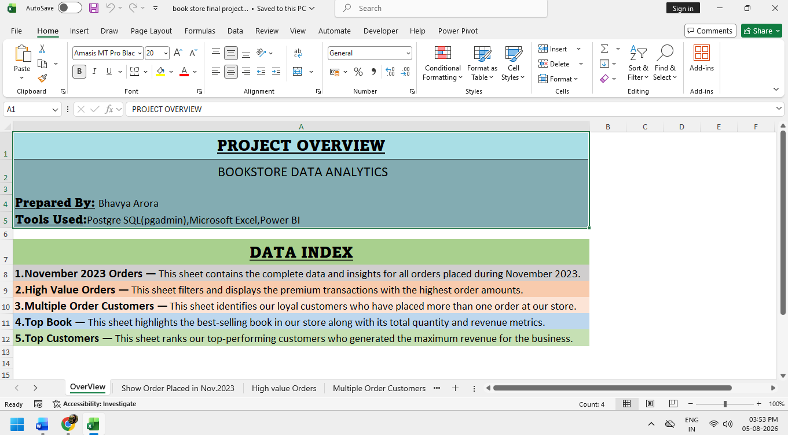
Step 2: Excel Data Cleaning & Visual Layout (Continued...)
(Figure 1: Microsoft Excel Project Overview Cover Page)
"Note: The complete processed data is structured across 5 distinct tabs inside this workbook (November Orders, High Value Orders, Multiple Order Customers, Top Book, and Top Customers). Default gridlines were hidden across all sheets, and uniform border styling was applied to ensure a professional repository."
Page 4: Step 3 – Power BI Business Intelligence
"The structured Excel data was imported into Power BI Desktop to construct a modern, dynamic, and interactive Executive Dashboard."
Key Steps Executed:
- Data Modelling: Connected the 5 imported sheets inside the Model View to ensure cross-filtering worked seamlessly.
- DAX Formulas: Developed custom calculations using SUM and DISTINCTCOUNT measures to retain exact transactional accuracy without distortion.
- Dashboard Design Elements:
- Daily Sales Trend: Created a smooth, high-impact Area Chart tracking November 2023 sales waves.
- High Value Orders: Built a Line Chart with a Continuous Time Axis and an active Zoom Slider for scrolling massive data without visual crowding.
- Loyal Customers Details: Formatted a sleek Data Table featuring clean White Gridlines for a high-contrast premium look.
- KPI & Summary Cards: Configured a Classic Card and Multi-Row Card complete with a custom Accent Bar and White Glow Shadow Effects to cleanly display the 'Best Selling Book' and 'Top Customers Revenue' without text overlap.

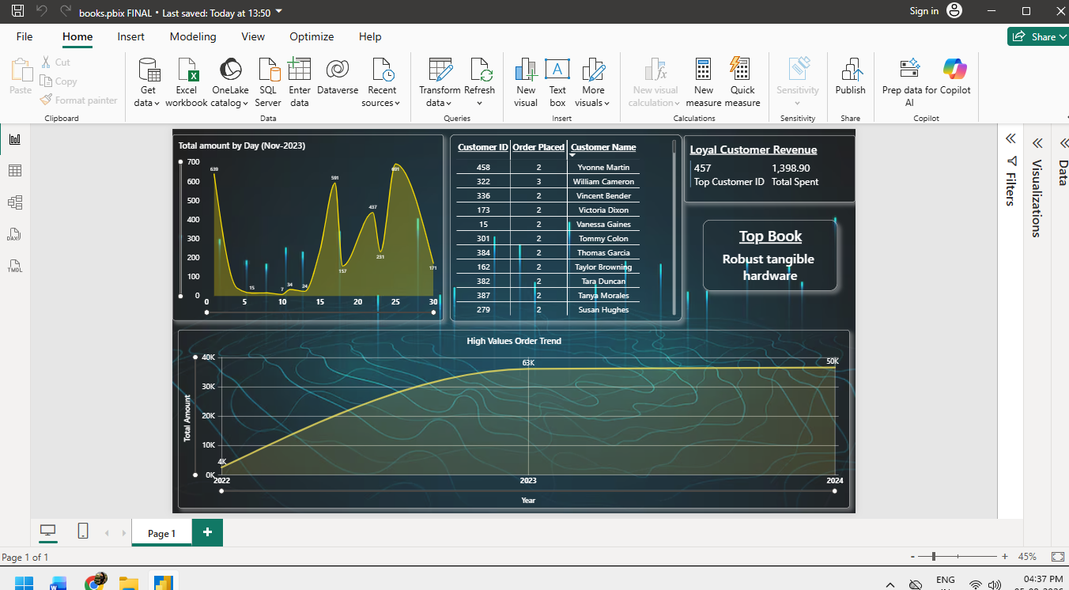
(Figure 2: Final Power BI Executive Bookstore Dashboard Layout)

